**Installation of Talend cloud Dynamic Engine**

Approval

| Signatures by each signatory indicate their acceptance that this document is complete and accurate to the best of his/her knowledge per responsibilities outlined in this document and as guided by approved methodologies and established procedures. | | |
| --- | --- | --- |
| Team Lead:  Artha Emp |  | **Date:** |
| Project Manager:  Artha Emp | **Deepthi Dharamsagar** | **Date:** |
| Talend Developer:  Artha Emp | **Omkar patil** | **Date:** |

**Step1: -**

**Install the Docker On Linux machine and Check the Version**

**docker --version**

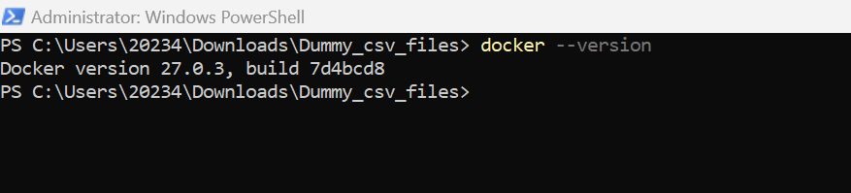

**Step2: -**

**Install the Kubernetes on the server and check the version**

**kubectl version**

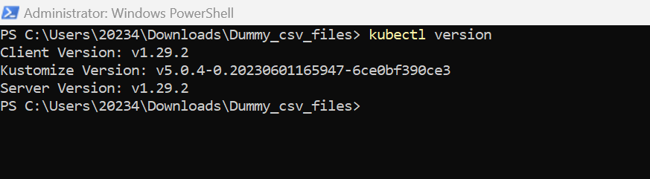

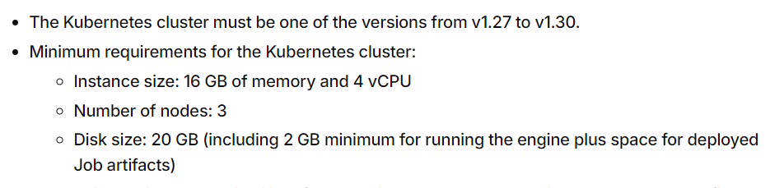

**Step3: -**

**Pre-requisites of Dynamic Engine**

[**https://help.talend.com/en-US/dynamic-engine-configuration-guide/Cloud/prerequisits-to-use-dynamic-engines**](https://help.talend.com/en-US/dynamic-engine-configuration-guide/Cloud/prerequisits-to-use-dynamic-engines)

**Step4: -**

**Create the Dynamic Engine on Cloud**

[**https://help.talend.com/en-US/dynamic-engine-configuration-guide/Cloud/set-up-dynamic-engine-on-registered-kubernetes-cluster**](https://help.talend.com/en-US/dynamic-engine-configuration-guide/Cloud/set-up-dynamic-engine-on-registered-kubernetes-cluster)

**In the Processing create the Dynamic Engine and Download the manifest file and Extract it.**

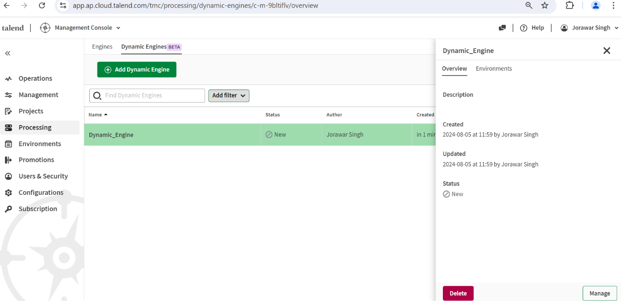

**Step 5: -**

**Run the *custom-resource-definitions.yaml *resources.yaml**

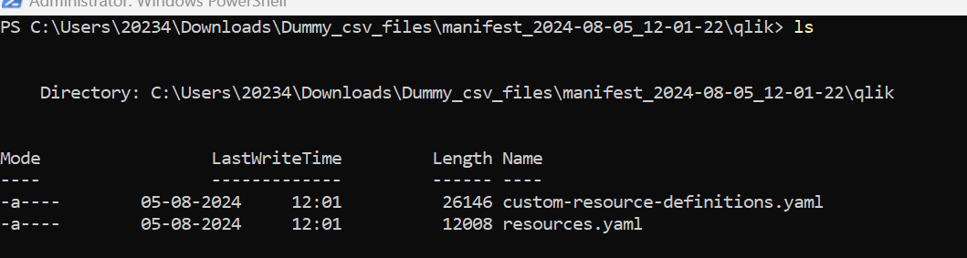

kubectl apply -f custom-resource-definitions.yaml

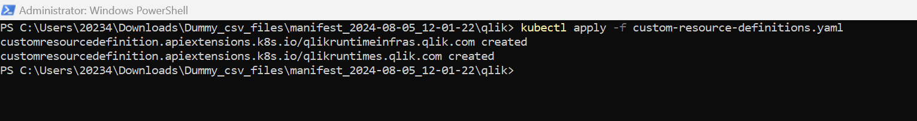

kubectl apply -f resources.yaml

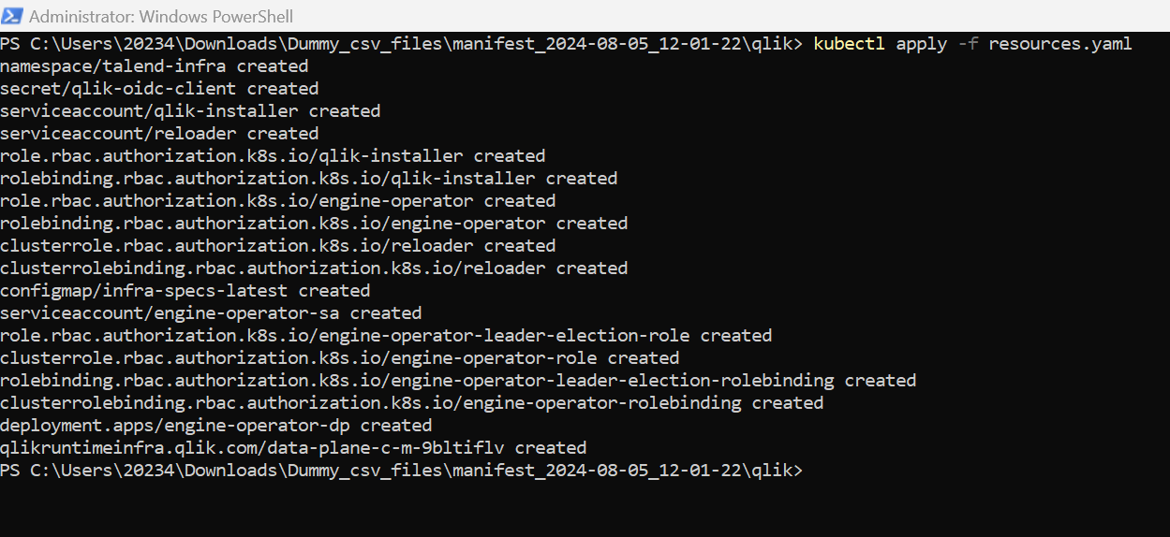

**Step 6: -**

**Check the status of Dynamic Engine It Should Be active**

**Once the Dynamic Engine Is Active Create the Environment and workspace and It to Dynamic Engine.**

**Step 7: -**

**Once the Environment is assigned Download the created manifest file.**

**Step 8: -**

**Run the .yaml file**

kubectl apply -f <your_environment_manifest_file>.yaml

**Step 9: -**

**Check the Dynamic Engine Key**

**Copy the Dynamic Engine Key and Check the all Dynamic Engine Services by using the key**

**Key will be works as like the separate namespace for Dynamic engine**

kubectl get qlikruntime remote-engine-0f719636-6d65-48f0-92c3-a3e987447ab1 -o json | jq -r '.status.conditions'